Practical No 6

**Aim:** To solve queries using the concept of sub query

**Problem Definition:**

(Based on University Schema)

1. Find all the courses taught in the both the Fall 2017 and Spring 2018 semesters

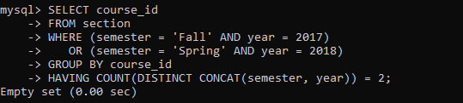

1. Find all the courses taught in the Fall 2017 semester but not in the Spring 2018 semester

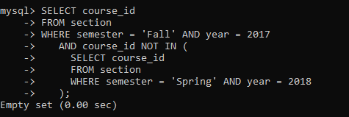

1. Find the total number of (distinct) students who have taken course sections taught by the instructor with ID 110011

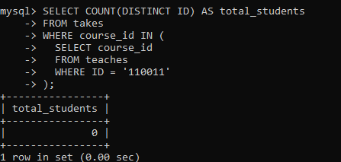

1. Find the names of all instructors whose salary is greater than at least one instructor in the Biology department

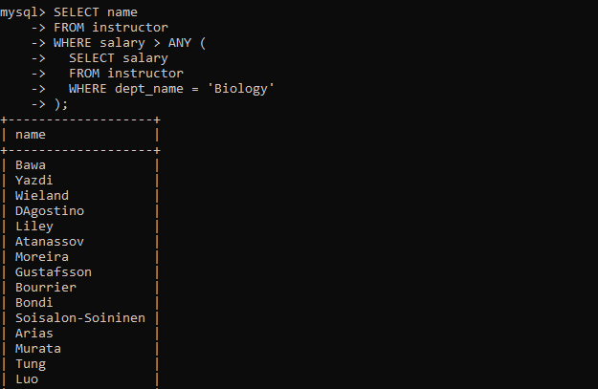

1. Find the names of all instructors that have a salary value greater than that of each instructor in the Biology department

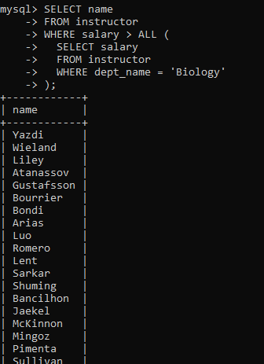

1. Find the departments that have the highest average salary

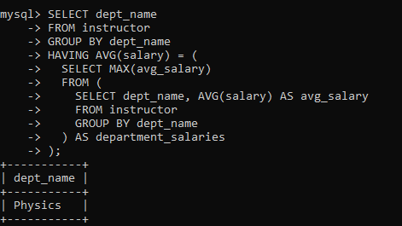

1. Find the average instructors’ salaries of those departments where the average salary is greater than $42,000

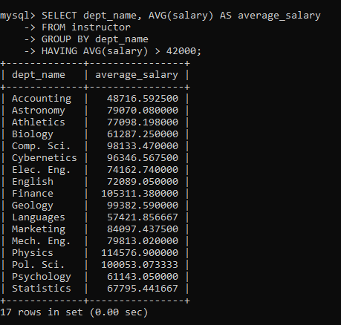

1. Find the maximum across all departments of the total of all instructors’ salaries in each department

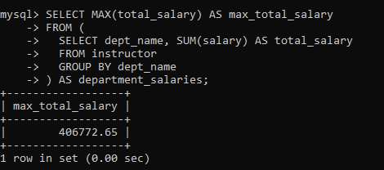

1. Lists all departments along with the number of instructors in each department

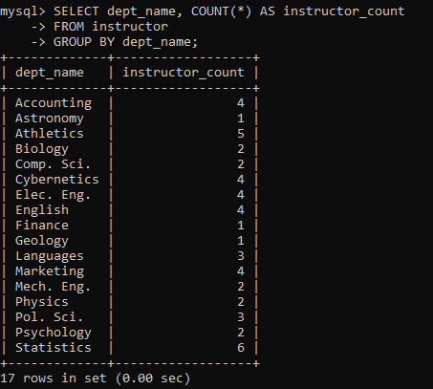

1. Find all instructors earning the highest salary (there may be more than one with the same salary).

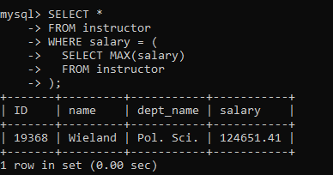

1. Find the enrolment of each section that was offered in Fall 2017.

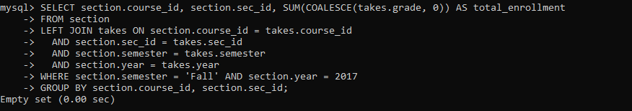

1. Find the maximum enrolment, across all sections, in Fall 2017

